EXPERIMENT:1A

CODE:
clc;
clc;
clear;
close all;

%% TE10 Mode Simulation - WR90 Waveguide

% Waveguide dimensions
a = 22.86e-3; % Width in meters
b = 10.16e-3; % Height in meters
L = 100e-3; % Length in meters

% Operating frequency
f = 10e9; % 10 GHz

% Speed of light
c = 3e8;

%% 1. Theoretical Cutoff Frequency

fc = c/(2*a);

fprintf('TE10 Cutoff Frequency = %.4f GHz\n', fc/1e9);

%% 2. Propagation Constant

beta = (2*pi*f/c)*sqrt(1-(fc/f)^2);

fprintf('Propagation Constant = %.4f rad/m\n', beta);

%% 3. Percentage Deviation
% Enter HFSS simulated cutoff frequency here
fc_HFSS = 6.557e9; % Example HFSS value

deviation = abs((fc_HFSS-fc)/fc)*100;

fprintf('Percentage Deviation = %.4f %%\n', deviation);

%% 4. Waveguide Grid

x = linspace(0,a,100);
y = linspace(0,b,60);

[X,Y] = meshgrid(x,y);

%% 5. TE10 E-field Distribution

% Normalized transverse electric field
Ey = sin(pi*X/a);

figure;
surf(X*1000,Y*1000,Ey);
shading interp;
xlabel('x (mm)');
ylabel('y (mm)');
zlabel('Normalized E-field');
title('TE10 Mode - E-field Distribution');
colorbar;
view(2);

%% 6. TE10 H-field Distribution

Hx = sin(pi*X/a);

figure;
surf(X*1000,Y*1000,Hx);
shading interp;
xlabel('x (mm)');
ylabel('y (mm)');
zlabel('Normalized H-field');
title('TE10 Mode - H-field Distribution');
colorbar;
view(2);

%% 7. Display Results

fprintf('\n===== TE10 RESULTS =====\n');
fprintf('Waveguide width a = %.2f mm\n',a*1000);
fprintf('Waveguide height b = %.2f mm\n',b*1000);
fprintf('Operating frequency = %.2f GHz\n',f/1e9);
fprintf('Theoretical fc = %.4f GHz\n',fc/1e9);
fprintf('Beta = %.4f rad/m\n',beta);
fprintf('HFSS fc = %.4f GHz\n',fc_HFSS/1e9);
fprintf('Percentage deviation = %.4f %%\n',deviation);
OUTPUT:

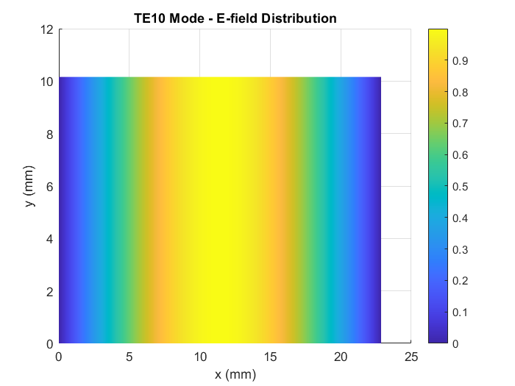

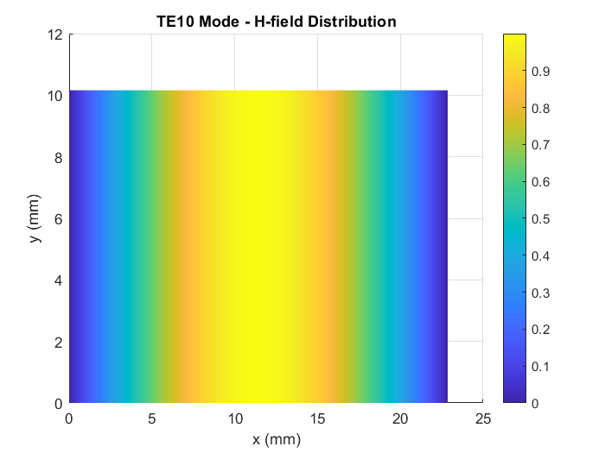
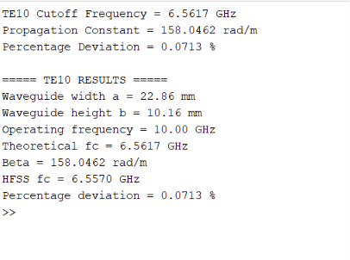
EXPERIMENT: 1B
Code:
clc;
clear;
close all;

%% TE10 versus TM11 - WR90 Waveguide

% Waveguide dimensions
a = 22.86e-3; % Width in meters
b = 10.16e-3; % Height in meters

% Operating frequency
f = 10e9; % 10 GHz

% Speed of light
c = 3e8;

%% 1. Cutoff Frequencies

% TE10
m1 = 1;
n1 = 0;

fc_TE10 = (c/2)*sqrt((m1/a)^2 + (n1/b)^2);

% TM11
m2 = 1;
n2 = 1;

fc_TM11 = (c/2)*sqrt((m2/a)^2 + (n2/b)^2);

fprintf('TE10 Cutoff Frequency = %.4f GHz\n',fc_TE10/1e9);
fprintf('TM11 Cutoff Frequency = %.4f GHz\n',fc_TM11/1e9);

%% 2. TE10 Propagation Constant

beta_TE10 = (2*pi*f/c)*sqrt(1-(fc_TE10/f)^2);

fprintf('\nTE10 Propagation Constant = %.4f rad/m\n',beta_TE10);

%% 3. TM11 Condition

if f > fc_TM11

beta_TM11 = (2*pi*f/c)*sqrt(1-(fc_TM11/f)^2);

fprintf('TM11 propagates.\n');
fprintf('TM11 Propagation Constant = %.4f rad/m\n',beta_TM11);

else

alpha_TM11 = (2*pi*f/c)*sqrt((fc_TM11/f)^2-1);

fprintf('TM11 is BELOW CUT-OFF.\n');
fprintf('TM11 Attenuation Constant = %.4f Np/m\n',alpha_TM11);

end

%% 4. Waveguide Grid

x = linspace(0,a,100);
y = linspace(0,b,60);

[X,Y] = meshgrid(x,y);

%% 5. TE10 E-field Distribution

E_TE10 = sin(pi*X/a);

figure;
surf(X*1000,Y*1000,E_TE10);
shading interp;
xlabel('x (mm)');
ylabel('y (mm)');
zlabel('Normalized E-field');
title('TE10 - E-field Distribution');
colorbar;
view(2);

%% 6. TE10 H-field Distribution

H_TE10 = sin(pi*X/a);

figure;
surf(X*1000,Y*1000,H_TE10);
shading interp;
xlabel('x (mm)');
ylabel('y (mm)');
zlabel('Normalized H-field');
title('TE10 - H-field Distribution');
colorbar;
view(2);

%% 7. TM11 E-field Distribution

E_TM11 = sin(pi*X/a).*sin(pi*Y/b);

figure;
surf(X*1000,Y*1000,E_TM11);
shading interp;
xlabel('x (mm)');
ylabel('y (mm)');
zlabel('Normalized E-field');
title('TM11 - E-field Distribution');
colorbar;
view(2);

%% 8. TM11 H-field Distribution

H_TM11 = sin(pi*X/a).*sin(pi*Y/b);

figure;
surf(X*1000,Y*1000,H_TM11);
shading interp;
xlabel('x (mm)');
ylabel('y (mm)');
zlabel('Normalized H-field');
title('TM11 - H-field Distribution');
colorbar;
view(2);

%% 9. Comparison of Modes

fprintf('\n====================================\n');
fprintf(' TE10 vs TM11 RESULTS\n');
fprintf('====================================\n');

fprintf('Operating Frequency = %.2f GHz\n',f/1e9);

fprintf('\nTE10:\n');
fprintf('Cutoff Frequency = %.4f GHz\n',fc_TE10/1e9);
fprintf('Propagation Constant = %.4f rad/m\n',beta_TE10);

fprintf('\nTM11:\n');
fprintf('Cutoff Frequency = %.4f GHz\n',fc_TM11/1e9);

if f < fc_TM11
fprintf('Status = BELOW CUT-OFF\n');
fprintf('TM11 does NOT propagate at 10 GHz.\n');
else
fprintf('Status = ABOVE CUT-OFF\n');
end

fprintf('\nConclusion:\n');

if f > fc_TE10 && f < fc_TM11
fprintf('TE10 propagates at 10 GHz because f > fc(TE10).\n');
fprintf('TM11 does not propagate because f < fc(TM11).\n');
end

OUTPUT:


